How to deploy Worklight Console on bluemix

1.Create Liberty for Java Application named “firstwl” on Bluemix.

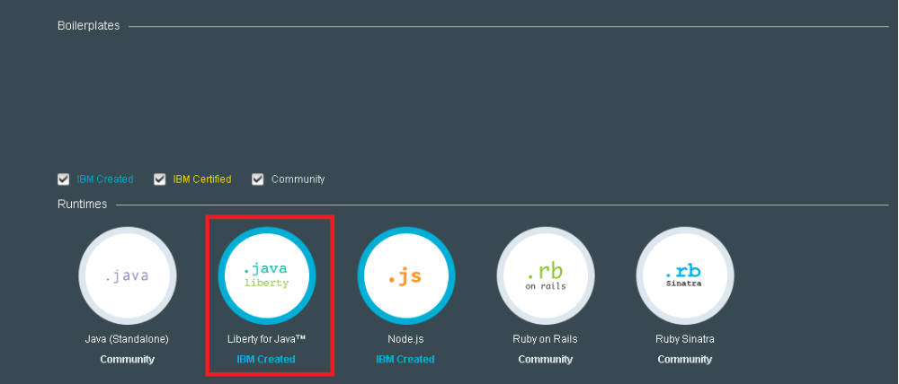

2.Find out where is the folder included Worklight Development Server in Eclipse

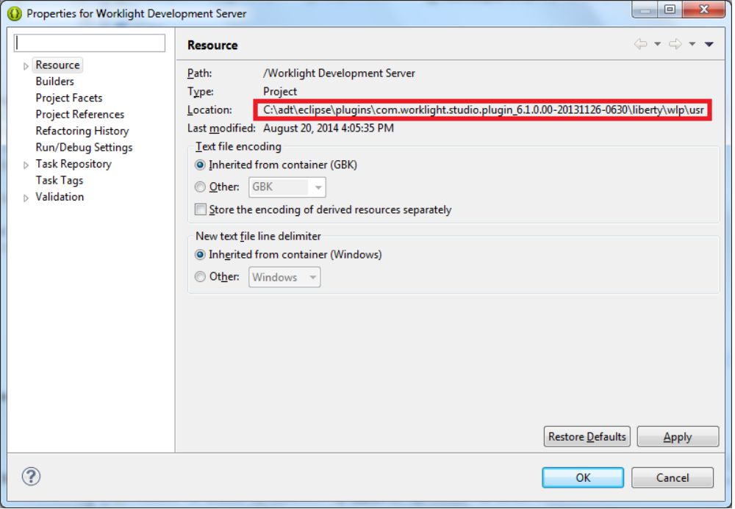
3.Package Liberty server with the server package command

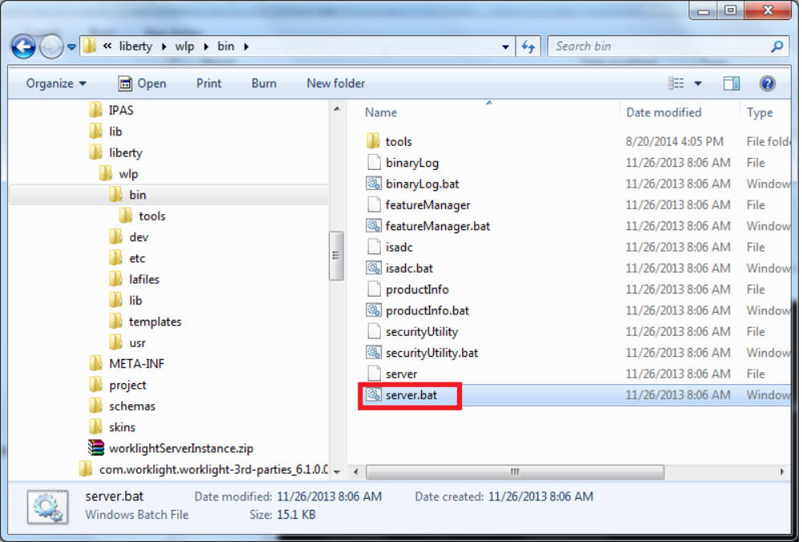

Execute shell command : server package server2 –include=usr

4.Add jar files on liberty package(server2.zip)
  - Open server2.zip and find out stsnode.war in apps folder
  - Open stsnode.war and find out folder “/WEB-INFO/lib”
  - Append jar files to folder “/WEB-INFO/lib” from source folder on liberty server.

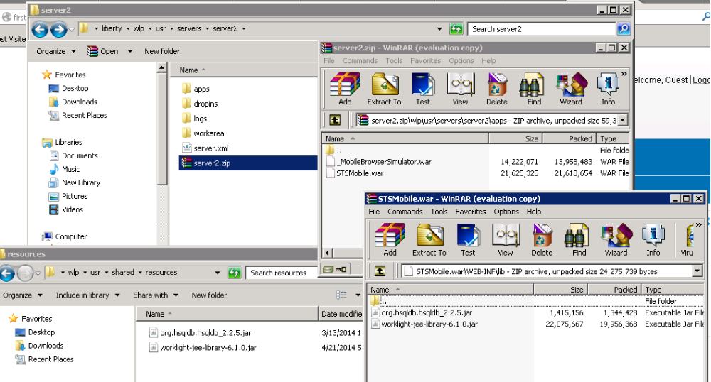
5.Push the resulting packaged server with cf push command
Execute command : cf push firstwl -m 512m -p server2.zip

6.Open Worklight Console page on Bluemix to deploy your application and adapter

